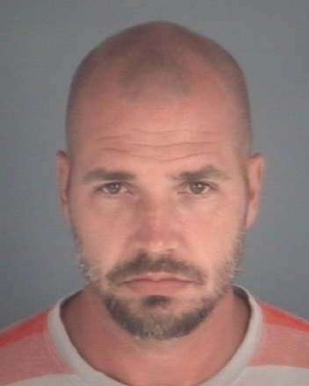
Scott Kevin Shoenberger
W/M 08-13-72 HGT: 5’09 WGT: 165
Charge: Sexual Battery/Fail to report residence Last Known Address: Washington Ave. Green Cove Springs, Fl.

Frederick Douglass Thomas
B/M 01-04-70 HGT: 5’11 WGT: 135
Charge: VOP Child Abuse Last Known Address: E. Forsyth ST. Jacksonville, Fl.
Cordairo Zeebedee Brown
B/M 09-22-86 HGT: 5’07 WGT: 150
Charge: VOP Interference with Custody Last Known Address: Thornbrook Dr. Jacksonville, Fl.
Crystal Lynn Bauder
W/F 11-03-79 HGT: 5’05 WGT: 142
Charge: VOP Child Neglect or Abuse Last Known Address: Dames Point Crossing Jacksonville, Fl.
Micheal Jerode McCray
B/M HGT: 5’11 WGT: 170
Charge: VOP Grand Theft Auto Last Known Adress: NE 37th Place Gainseville, Fl.
Teresha Lashell Miller
B/F 11-03-96 HGT: 5’02 WGT: 180
Charge: VOP Grand Theft Last Known Address: North 21st St. Palatka, Fl.
Lenodar Elaine Milton
B/F 10-30-85 HGT: 5’04 WGT: 135
Charge: VOP Organized Fraud/Dwlsr Last Known Address: NE 25th Ct Ocala, Fl.
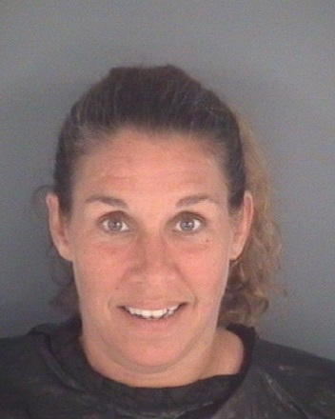
Althea Lorraine Aikens
W/F 01-13-74 HGT: 5’03 WGT: 138
Charge: VOP Domestic Battery Last Known Address: 103rd St. Jacksonville, Fl.
Joan Ann Boyd
W/F 11-25-79 HGT: 5’04 WGT: 180
Charge: VOP Petit Theft Last Known Address: Pearwood Cir Middleburg, Fl.

Shawn Dustin Shull
W/M 10-05-89 HGT: 6’06 WGT: 189
Charge: VOP Use or Possess Drug Paraphernalia/Dwlsr/Leaving Scene of a Crash
Last Known Address: Lourdes Dr. Jacksonville, Fl.
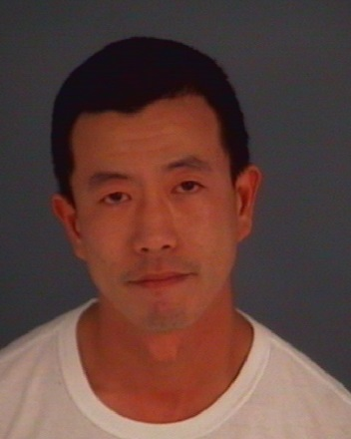
Evan David Treffinger
A/M 01-04-80 HGT: 5’06 WGT: 125
Charge: VOP Dui Last Known Address: Post St. Jacksonville, Fl.
Rosa Pauline Kirk
W/F 07-30-73 HGT: 5’01 WGT: 130
Charge: FTA Dwlsr Last Known Address: W. 11th St. Atlantic Bch.

