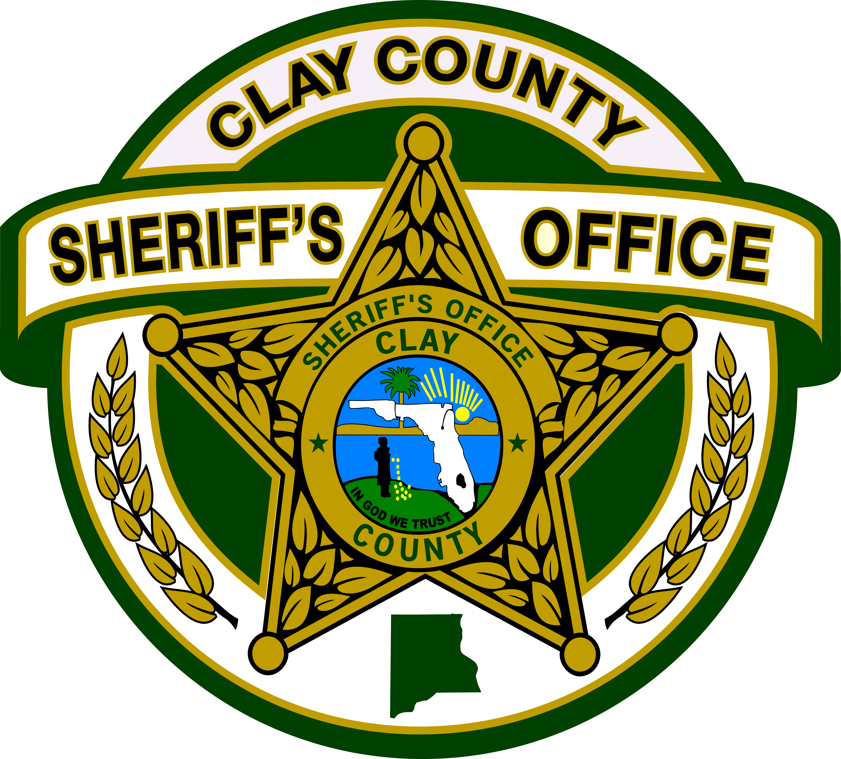

CLAY COUNTY SHERIFF’S OFFICE
SHERIFF DARRYL DANIELS
P.O. BOX 548
(904) 264-6512 or (352) 473-7211
FAX (904) 284-0710
GREEN COVE SPRINGS, FLORIDA 32043-0548
____________________________________________________________

February 21, 2018,

Subject: Request for Proposal B18-002, Towing and Wrecker Services

In reference to the above solicitation, the Clay County Sheriff’s Office has determined it is in its best interest to reject all responses pursuant to paragraph 8 of the Invitation of this solicitation. The Clay County Sheriff’s Office intends to reissue a new solicitation in the near future. Accordingly, the rejected responses remain exempt from disclosure in accordance with Section 119.071 (1) (b) 3, Florida Statutes.

If you have questions, please contact Rhonda Sanders, Purchasing Manager at 904-213-6029.

