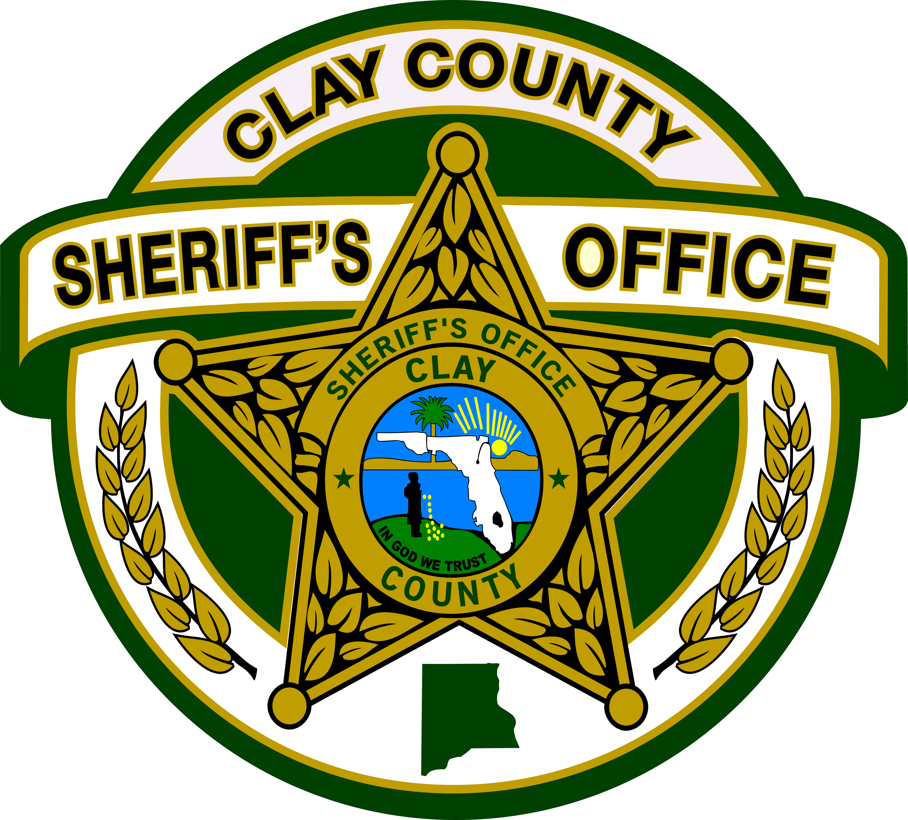

CLAY COUNTY SHERIFF’S OFFICE
SHERIFF DARRYL DANIELS
P.O. BOX 548
(904) 264-6512 or (352) 473-7211
FAX (904) 284-0710
GREEN COVE SPRINGS, FLORIDA 32043-0548
____________________________________________________________

Promotional Process and Development
RFP B18-004

Addendum 1
March 2, 2018

- Question posed:

On the Cost Proposal Worksheet, it asks for the administration costs in blocks of 10. Does the department anticipate administering the written exam to only 10 candidates at a time? In order to maintain test security, we typically recommend administering written exams in a single session, as it creates a uniform testing experience for candidates at each rank.

Response:

Each positional exam will be administered in a single session. The Cost Proposal Worksheet breaks it down to blocks of 10 for cost purposes only. If the number of candidates exceeds 10, the cost will be adjusted accordingly. For example: if there are 49 candidates for the Law Enforcement Sergeant, the cost for the block of 10 will be multiplied by 5.

