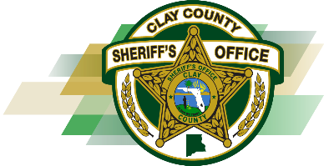
CLAY COUNTY SHERIFF’S OFFICE
Sheriff Michelle Cook
P.O. BOX 548
(904) 264-6512 or (352) 473-7211
FAX (904) 284-0710
GREEN COVE SPRINGS, FLORIDA 32043-0548
____________________________________________________________

Issued: February 10, 2021

Clarification No. 1

Request for Proposal (RFP) #: B21-001

Project Name: Inmate Transport and Hospital Watch

Due Date: February 22, 2021

The following clarification is for the above Request for Proposal:

- My company currently carries $100,000 of commercial vehicle liability insurance. I wanted to know if that will satisfy your insurance requirements for prisoner transport.

Response: No, the minimum allowable Commercial Automobile Liability coverage is $500,000 combined bodily injury/property damage.

